Basic Chemistry Name: Date: Period:

Elements! __________________________________________________________________________________________________________________________________________________________________________

Four elements make up 96% of biotic things!

__________________
__________________
__________________
__________________

Elements have a one or two letter symbol. It’s an easier way to refer to them, like a nickname.
Some elements and their symbols:

Atoms!
____________________________________________________________________________________________________________________________________________________________

Atoms are made of three particles:
1. ______________________________ are __________________.
2. ______________________________ are __________________.
3. ______________________________ are ___________________.

But where do all these particles live?
The protons and neutrons live in the ___________________. The electrons ________________ around the nucleus. Draw a picture of an atom here. Label the protons, neutrons, and electrons.

Do protons, neutrons, and electrons get along?
It depends on their charge!! Think of how magnets react when you try to put them together…
Positively charged things are _________________ to negatively charged things.
So ____________________________________________________!
Things that have the same charges are _____________________ by each other.
So _____________________________ and _________________________________

How do we figure out how many of each atomic particle an element has?
We can use the _______________________________ which lists all the elements! It also lists very essential things about them such as….
Atomic __________ =

Element’s Symbol

Element’s Name

Atomic ___________ =

6
C
Carbon
12.011

So the number of protons is equal to the ______________________________________. Carbon has _______ protons, ______ electrons, and an average of _______ neutrons.

Are electrons just floating around in space?
Electrons are arranged into ________________. They move around _______________________ which __________________ the nucleus.
The first shell can only hold ____ electrons.
The second shell can hold ______ electrons.
The third shell can hold ______ electrons.
When elements have full outer shells they are very STABLE. This is called the ______________ because ____________________________________________. The electrons in the outer shells are called ___________________ electrons.

Charge!
If an element has a net charge of zero (meaning it is neutral), then the ___________________________________________________________________.
What happens if the number of electrons doesn’t equal the number of protons?

This forms charged particles called _______________!
Think about where the subatomic particles live. Which one can move around? ______________

Sometimes electrons get ________________, ______________, or ______________ between atoms!

So if an atom GAINS an electron, it has a net ____________________ charge.
(more electrons and fewer protons will make it -)

If an atom LOSES an electron, it has a net _____________________ charge.
(fewer electrons and more protons will make it +)

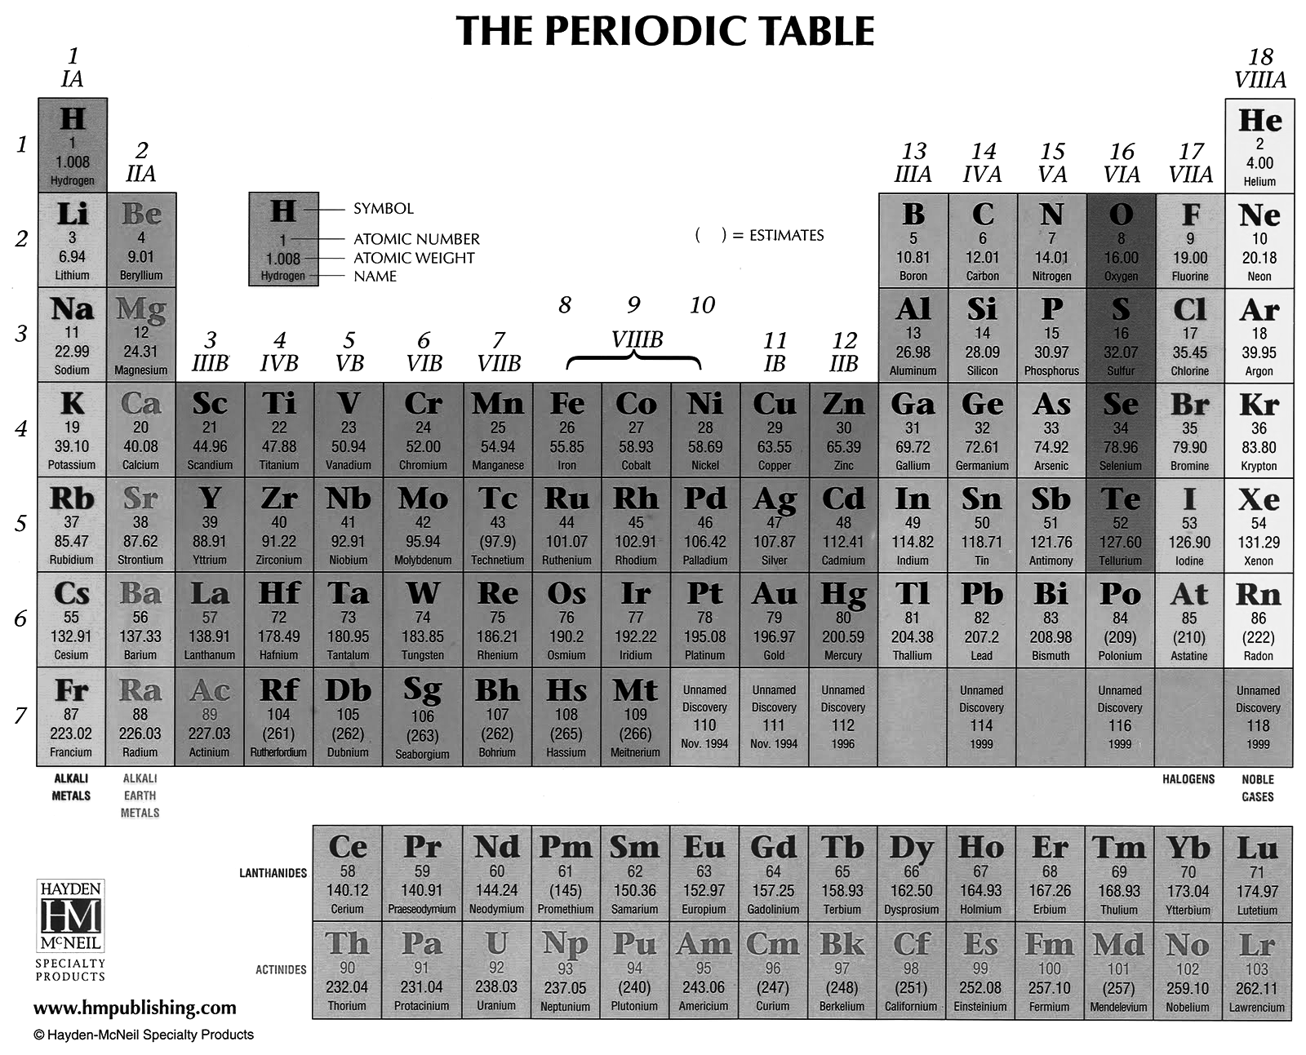

Periodic Table Basics
Bohr Diagram

Lewis Structure B
P= __5__

N= __6__

E=___5__
5
B
Boron
10.81

Step 1: Complete the squares for each element by filling in the atomic number, name, and atomic mass.
Write the atomic number at the top of the square.

Write the element’s name under the symbol.

Write the atomic mass at the bottom of the square.

Step 2: Determine the number of protons, neutrons, and electrons in each element.
Use your notes to help you. The number of electrons
are for a neutral element.

Step 3: Create a Bohr diagram for each element.

Step 4: Draw the Lewis Structure for each element.

Step 5: Cut the cards apart and arrange according to atomic number in the pattern shown below. Once you have the cards arranged in the correct order, glue them to a sheet of paper or a large sheet of constructution paper.

1 |  |  |  |  |  |  | 2
3 | 4 | 5 | 6 | 7 | 8 | 9 | 10
11 | 12 | 13 | 14 | 15 | 16 | 17 | 18

Step 6: Answer the questions on the next page using the information on your Periodic Table and your notes.

Name: _____________________________
Date: ______________________
Period: __________

Getting to know the Periodic Table of Elements
Answer the following questions in complete sentences once you have finished making your periodic table. Refer back to your notes for definitions and examples!

- Which elements had complete outer shells? Give the name and symbol for each.
__________________ _____ __________________ _____ __________________ _____
- What do you notice about the location of the elements you listed in question 1?

- Which elements had only one valence electron (electrons in the outermost shell)?
__________________ _____ __________________ _____ __________________ _____
- What do you notice about the location of the elements you listed in question 2?

- What do you notice about the number of valence electrons as you move from left to right across a row or period in the periodic table? (Li BeBCNOFNe)

- Use your periodic table to predict the number of valence electrons for the following elements.
Calcium = _________ Lead = ________ Potassium = _________ Iodine = ___________

- What do you notice about the number of energy levels or shells as you move down a group or column in the periodic table? (HLiNa)

- What is unique about hydrogen?

The periodic table is organized in a very specific way and groups elements according to their physical and chemical properties.

_____
C
_________
_____
Bohr Diagram

Lewis Structure C
P= _____

N= _____

E=_____

_____
H
_________
_____
Bohr Diagram

Lewis Structure H
P= _____

N= _____

E=_____

_____
P
_________
_____
Bohr Diagram

Lewis Structure P
P= _____

N= _____

E=_____

_____
He
_________
_____
Bohr Diagram

Lewis Structure He
P= _____

N= _____

E=_____

_____
S
_________
_____
P= _____

N= _____

E=_____

_____
Mg
_________
_____
P= _____

N= _____

E=_____

_____
B
_________
_____
Bohr Diagram

Lewis Structure B
P= _____

N= _____

E=_____

_____
Li
_________
_____
Bohr Diagram

Lewis Structure Li
P= _____

N= _____

E=_____

_____
Ne
_________
_____
Bohr Diagram

Lewis Structure Ne
P= _____

N= _____

E=_____

_____
Na
_________
_____
Bohr Diagram

Lewis Structure Na
P= _____

N= _____

E=_____

_____
Ar
_________
_____
Bohr Diagram

Lewis Structure Ar
P= _____

N= _____

E=_____

_____
Si
_________
_____
P= _____

N= _____

E=_____

_____
Al
_________
_____
P= _____

N= _____

E=_____

_____
Cl
_________
_____
P= _____

N= _____

E=_____

_____
Be
_________
_____
Bohr Diagram

Lewis Structure Be
P= _____

N= _____

E=_____

_____
O
_________
_____
Bohr Diagram

Lewis Structure O
P= _____

N= _____

E=_____

_____
N
_________
_____
Bohr Diagram

Lewis Structure N
P= _____

N= _____

E=_____

_____
F
_________
_____
Bohr Diagram

Lewis Structure F
P= _____

N= _____

E=_____

