Name Period _Date

Dihybrid Cross Worksheet

In rabbits, gray hair is dominant to white hair. Also in rabbits, black eyes are dominant to red eyes. These letters represent the genotypes of the rabbits:

GG = gray hair Gg = gray hair gg = white hair
BB = black eyes Bb = black eyes bb = red eyes

- What are the phenotypes (descriptions) of rabbits that have the following genotypes? Ggbb ggBB
ggbb GgBb

- A male rabbit with the genotype GGbb is crossed with a female rabbit with the genotype ggBb the square is set up below. Fill it out and determine the phenotypes and proportions in the offspring.

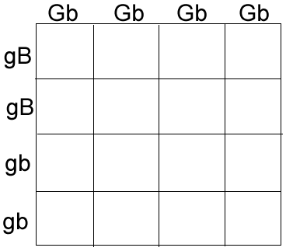How many out of 16 have gray fur and black eyes? How many out of 16 have gray fur and red eyes? How many out of 16 have white fur and black eyes?

How many out of 16 have white fur and red eyes

- A male rabbit with the genotype GgBb is crossed with a female rabbit with the genotype GgBb The square is set up below. Fill it out and determine the phenotypes and proportions of offspring

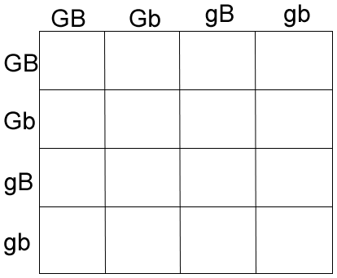How many out of 16 have gray fur and black eyes?

How many out of 16 have gray fur and red eyes?

How many out of 16 have white fur and black eyes?

How many out of 16 have white fur and red eyes?

- Show the cross between a ggBb and a GGBb. You'll have to set this one up yourself: Punnett Square:

- An aquatic arthropod called a Cyclops has antennae that are either smooth or barbed. The allele for barbs (B) is dominant over smooth (bb). In the same organism Non-resistance to pesticides (N) is dominant over resistance to pesticides (nn). Make a "key" to show all the possible genotypes (and phenotypes) of this organism.

Genotype Phenotype

BB
Bb Bb NN
Nn nn

- A Cyclops that is resistant to pesticides and has smooth antennae is crossed with one that is heterozygous for both traits. Show the genotypes of the parents.

x

- Set up a punnett square for the cross.

9. What are the phenotypic ratios of the offspring?

