Structure of DNA/Base Pairing

In your textbook, read section 12.1 (pages 287-294) about the structure and history of DNA.

Label the diagram below using the following choices:
Nucleotide, deoxyribose, phosphate group, nitrogen base, hydrogen bonds, base pair

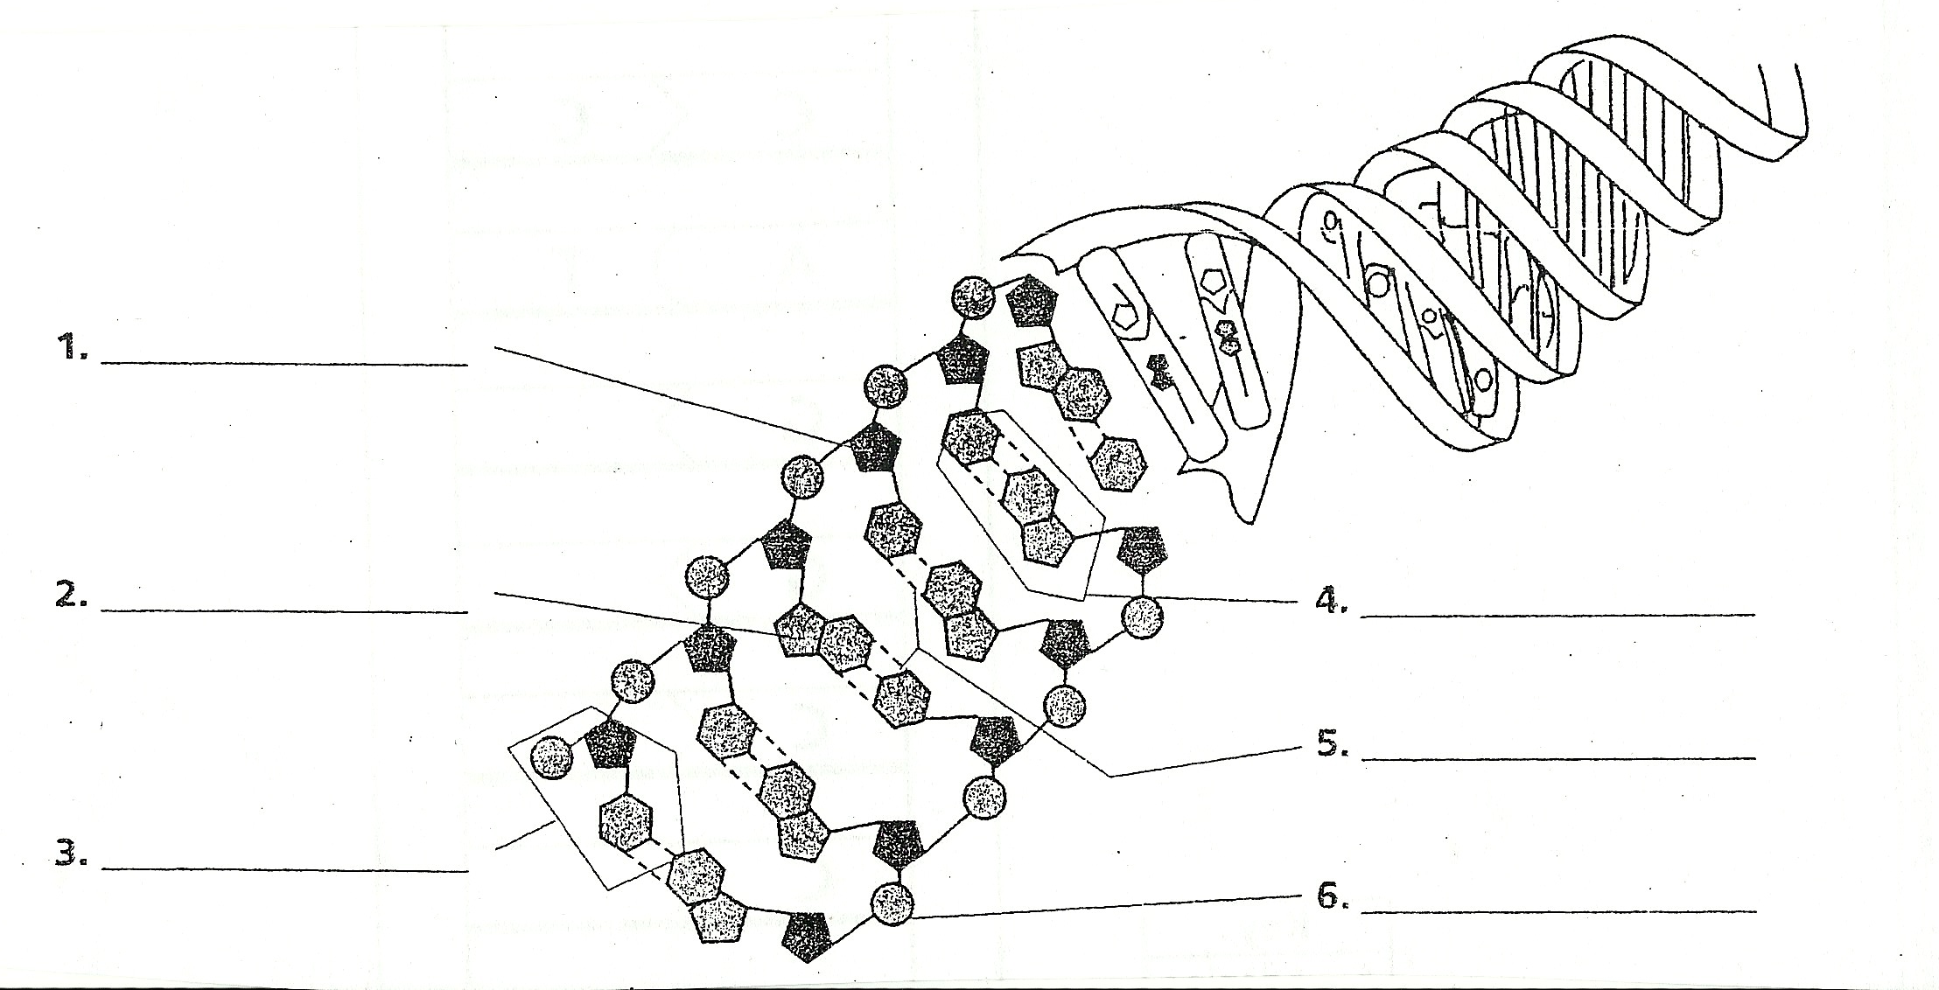

Complete each statement.

- _____________________, guanine (G), cytosine (C), and thymine (T) are the four ________________________ in DNA.
- In DNA, ___________________ always forms ________________________ bonds with guanine (G).
- The sequence of ________________________ carries the genetic information of an organism.
- The process of ____________________________ produces a new copy of an organism’s genetic information, which is passed on to a new cell.
- DNA synthesis occurs during ____________________ of interphase.
- The double-coiled shape of DNA is called a ____________________ _____________________.

Base Pairing

I. Four nucleotides make up DNA: adenine, cytosine, guanine, and thymine. These nucleotides always occur in pairs call base pairs. Write the missing letter to complete each base pair. The first two have been done for you.

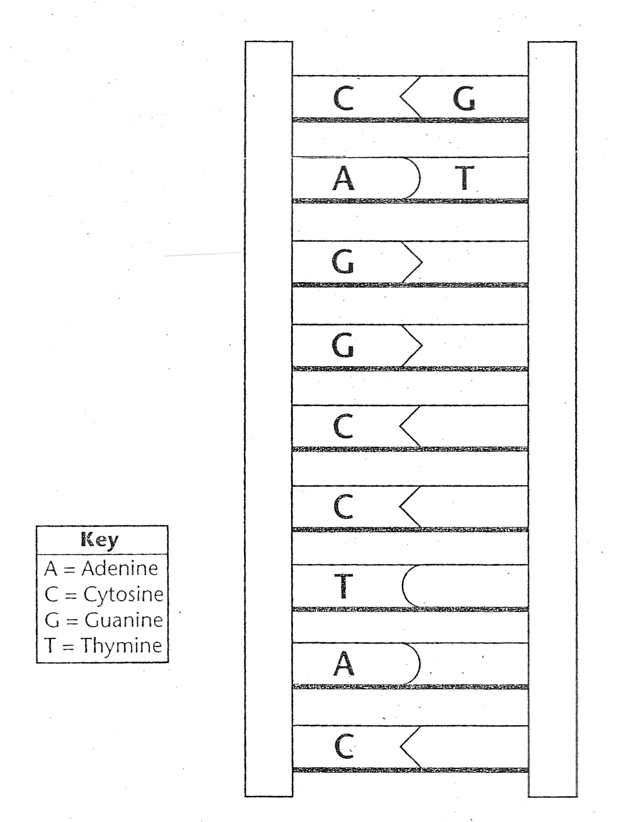
II. Use the diagram to answer the following questions.

- What nucleotide is always paired with thymine?

- What nucleotide is always paired with guanine?

- What type of bond connects base pairs?

