- Define Evolution:

- The key idea in natural selection is that individuals with advantageous traits will:

- What are Darwin’s 4 postulates?

- Be able to define the following terms AND be able to relate them to the image below:
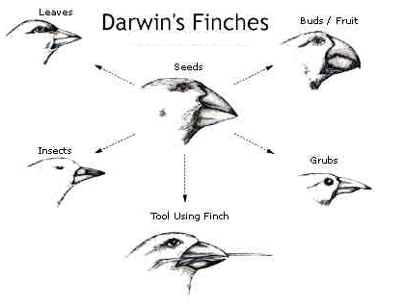
  - Speciation

  - Adaptive radiation

  - Descent with modification

- True or False: A(n) mutation always aids an organism in its environment. If false, what word should replace the underlined one?

- True or False: Most mutations are harmful. If false, explain why you think so.

- Explain how the following forms of evidence demonstrate/prove evolution:

  - Fossils

  - Homologous Structures

  - DNA

  - Vestigial Structures

  - Biogeography

  - Comparative Embryology

- Define Convergent Evolution and provide an example.

- When looking at sedimentary rock, the layers (strata) closest to the center of the earth are ________________ than those strata closest to the earth’s surface.

- Which pair of organisms probably has the most similar DNA?
  - Fish and humans
  - Snakes and chickens
  - Oak trees and elephant
  - Cats and dogs

- Explain Lamarck’s idea of Evolution and give an example.

- Who is the “father of Evolution” and author of “The Origin of Species”?

- Describe the set-up and result of the Miller & Urey “early life“ experiment.

- Which is used to provide evidence for the theory of evolution?
A. fossils
B. anatomy and embryology
C. biochemistry
D. all of the above

- Explain how antibiotic resistance relates to evolution.

- Describe the endosymbiont theory of eukaryotic cells. What organelles provide evidence to support this theory?

- Describe how reproductive isolation contributes to speciation. What are the 3 mechanisms of reproductive isolation?

- The most recent common ancestor for K and M is: (choose a letter from the diagram below)
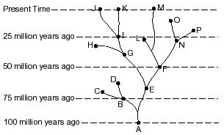
- Evolution takes place more rapidly among organisms that reproduce sexually rather than those that reproduce asexually. This is true because:
A. sexual reproduction is more hazardous than asexual reproduction, and only the fit survive.
B. asexual reproduction occurs only in one celled organisms.
C. sexual reproduction in more likely to produce a variety of offspring.
D. sexual reproduction is slower than asexual reproduction in producing offspring.

- Provide at least 2 examples of vestigial structures currently present in the human body.

- Explain what type of natural selection each of the following examples describes:
  - peppered moth:

  - human birth weight:

  - finch beak size:

- What conditions must be met in order to establish Hardy-Weinberg Equilibrium?

- What is the difference between punctuated equilibrium and gradualism?

- Draw what the graph for ideal (Hardy-Weinberg) allele frequencies in a population would look like. Then, draw the graphs for stabilizing, directional, and disruptive selection. (you can use another sheet if you run out of room)

