Dependent and Independent Variables

Graphing Practice

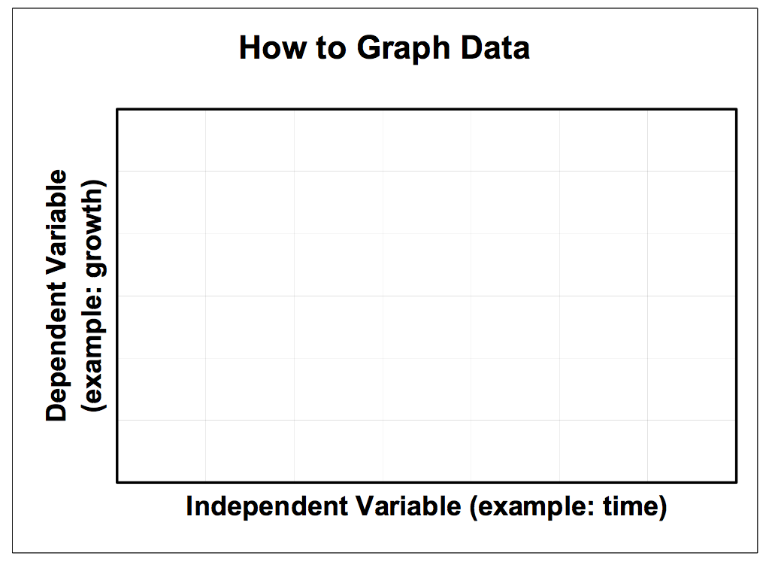
In order to properly graph information, the dependent and independent variables in a lab must be identified. Remember that the independent is the variable that you change and the measured result of that change is the dependent variable. The independent variable is on the x-axis and the dependent is on the y-axis.

In the following hypotheses, circle the dependent variables and underline the independent variables. Predict and draw what your graph will look like for each hypothesis (you will have 6 graphs total). Include all the important parts of the graph: title, labels, units and a key.

- Human heart rate will increase from sitting to standing and from standing to up-side-down.

- I have 3 different types of paper towels; I think type A will hold the most water, then B, then C.

- The height of the plant will increase through the test days (1-5).
- Adding sugar to water will increase the temperature at which water boils.

- Water will evaporate faster at higher temperatures than at lower temperatures.

- Wounds covered bandaids heal faster than wounds left in the open, but not as fast as wounds treated with Neosporin and covered with a bandaid.

