Step I: Warm-Up

Are these animals? Write a Y (yes) or N (no) beside each example.

____barnacle ____sponge ____moss ____ostrich
____algae ____sea star ____yeast ____bee
____bacteria ____bat ____tapeworm ____human
____rock ____robot ____jellyfish ____eel
____crystal ____clam ____snail ____coral reef

What characteristics did you use to determine your answer? What IS an animal?

Step II: Homework
Animals develop in a unique manner. Draw and explain each stage below.

Fertilization | Zygote
Blastula | Gastrulation

What is a germ layer?

Draw the three animal germ layers and describe their destiny/role in the body:

Put the following words in the correct sequence, beginning with the earliest:
Gastrula, adult, fertilized egg, blastula, embryo

What are the three types of symmetry in animals? Provide an example of an animal that exhibits each type of symmetry.

Define Cephalization.

What is another term for “body cavity”?

Label the following diagram with the terms: ventral, dorsal, posterior, anterior

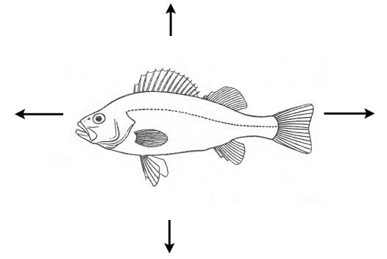

What percentage of animals are invertebrates?

Vertebrates appear in Phylum _____________________.

What are some examples of animals in phylum arthropoda? Phylum annelida?

