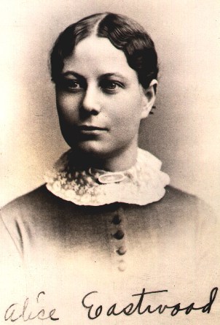
Alice Eastwood was famous for her ability to collect and also identify a wide variety of plants. Scientists accomplish this by using a method of classification called taxonomy, which gives us a tool called a dichotomous key. This is a step-by-step method of identifying plants or animals or, in this case, salty & crunchy snacks. You will do this by using the snack’s physical characteristics to separate the objects into individual “species.”

A dichotomous key is built on the idea of having to choose between two characteristics, and putting the object that you are evaluating into one category or the other. You are going to construct a dichotomous key for the snacks provided.

Materials you will need:
8 different types of salty, crunchy snacks (1 of each snack)
paper towels
pencil

Remember, your dichotomous key should look something like this:

*Your dichotomous key should be on a separate piece of paper, and it should be neat/organized! Each snack should have its own distinct classification.

Procedure

- Separate the snacks into two groups based on one observable characteristic. An example might be ruffled and not ruffled. Be sure to record the characteristic you used to separate the snacks.
  - You may want to consider literally placing each of your snacks on the table for this separation and building a model of what your dichotomous key might look like. Using your model, you can then draw your dichotomous key!
- Choose one group of snacks to start with and divide them into two additional groups, based on another characteristic. For instance, the ruffled chips might be separated by color. Smell, taste, size, shape, and anything else you can think of are all fair game for characteristics. Record the characteristic you used to separate this group.
- Keep dividing the groups and recording until only one sample remains in each category (e.g. until all snacks have been classified as unique individuals).
- On the final (paper) version of your dichotomous key, identify the snack with an imaginary scientific name. HAVE FUN WITH THIS! Remember the rules when writing scientific names by hand! DO NOT LABEL YOUR KEY WITH NAMES LIKE “DORITOS” or “PITA CHIPS” (See #5)!!!
  - Example: Ruffulus barbequeis, obviously named for a ruffled, BBQ-flavored chip
- Once you have completed your key, trade with another group. Select a specific chip (without telling them the scientific name) and see if they can identify the chip, using the key that you drew.
- If the other group used a snack that you did not include in your dichotomous key, see if it can be classified using your dichotomous key.
- Method of disposal for laboratory snacks is up to you. Paper towels should be thrown away, please!

